The Northwest Territory Today

Name _________________________________ Date __________________

Use the word box below to identify the lettered locations on the map.

Chicago Milwaukee Lake Erie

Columbus Indianapolis Lake Huron

Cleveland Lake Michigan Ohio River

Detroit Lake Ontario

Madison Lake Superior

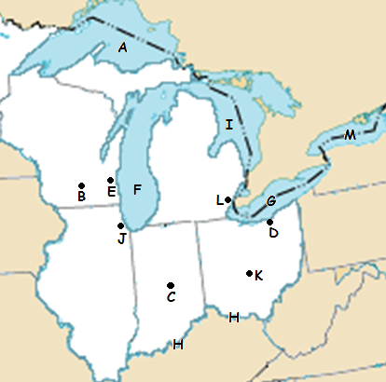

1. __________________ E. __________________ I. __________________
2. __________________ F. __________________ J. __________________
3. __________________ G. __________________ K. __________________
4. __________________ H. __________________ L. __________________

M. __________________